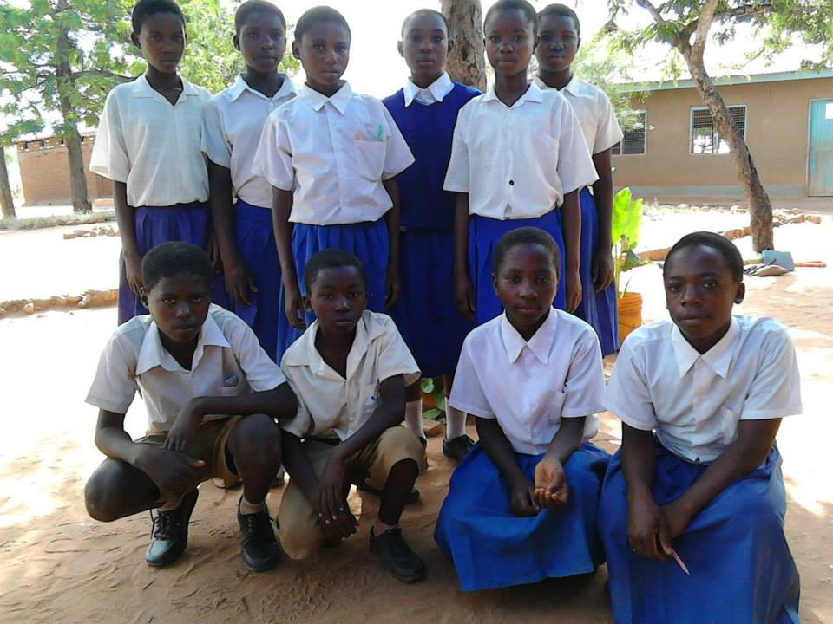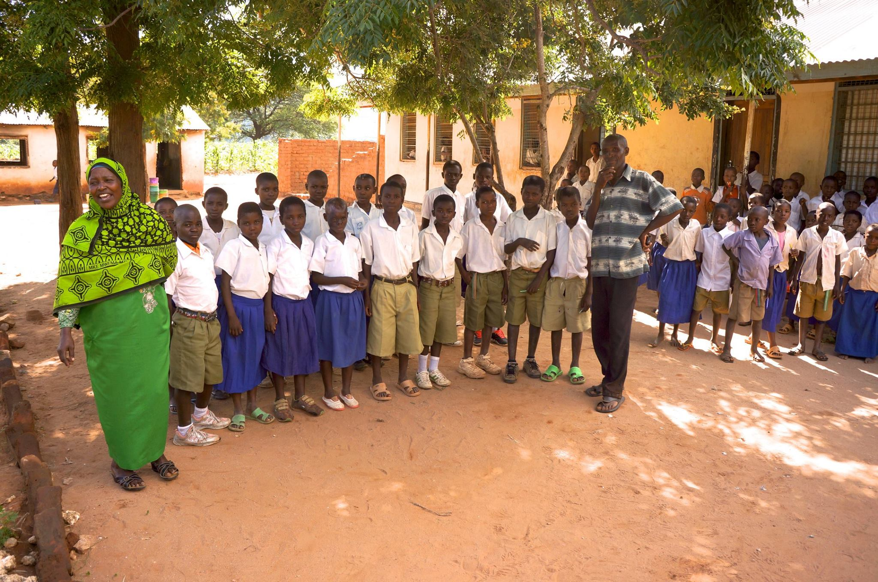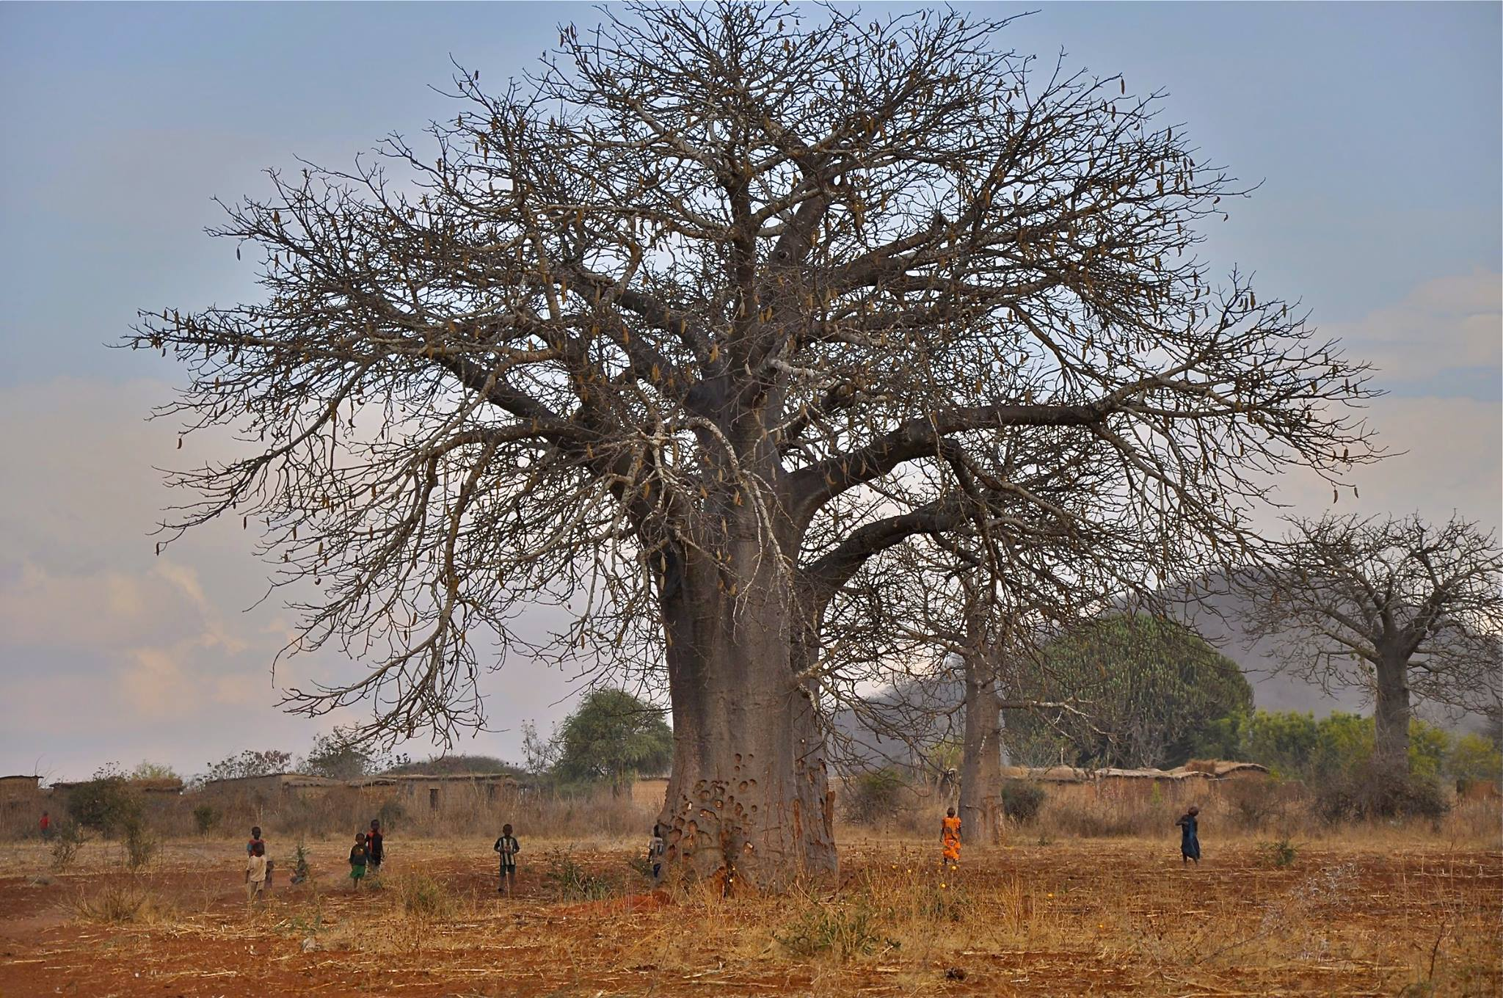 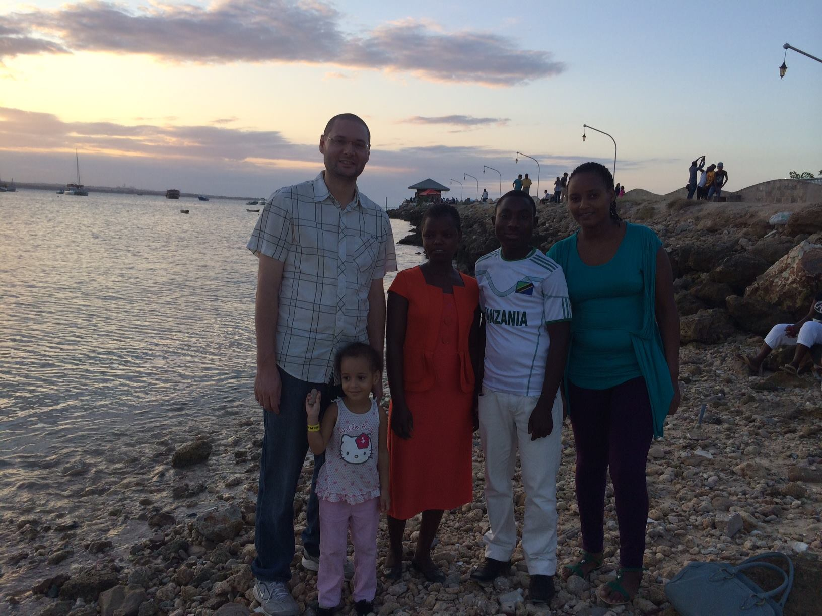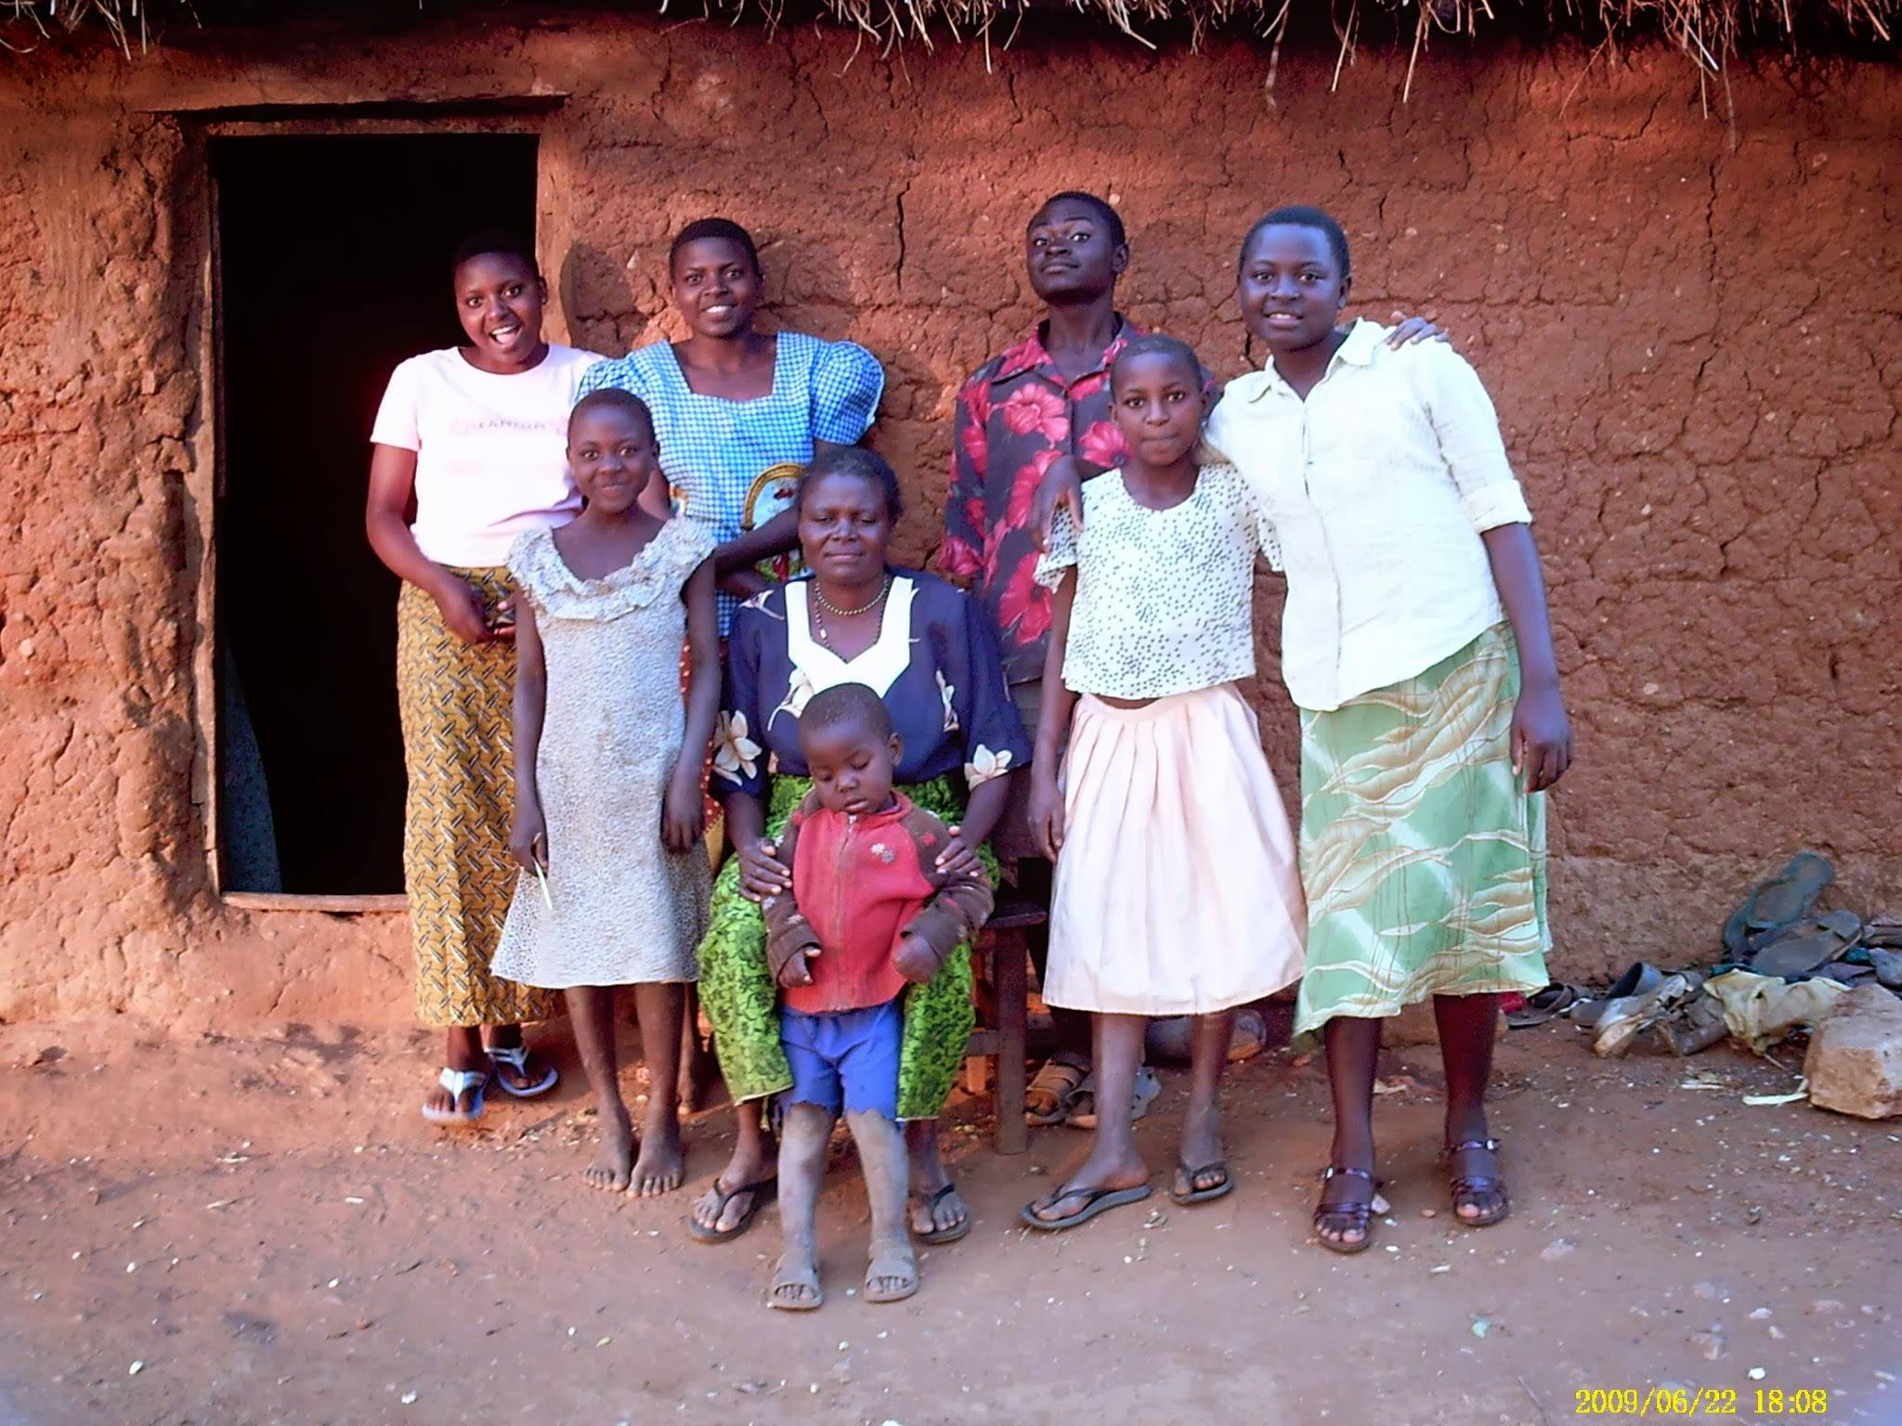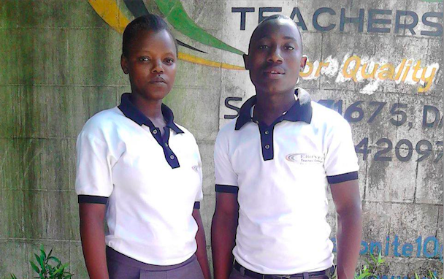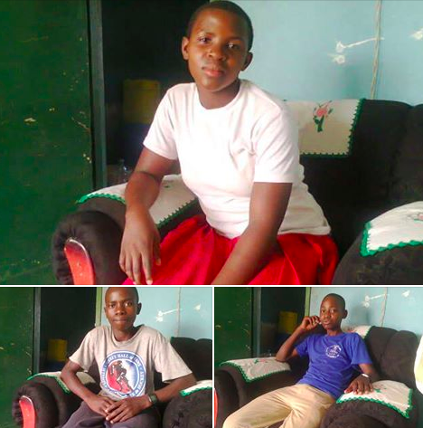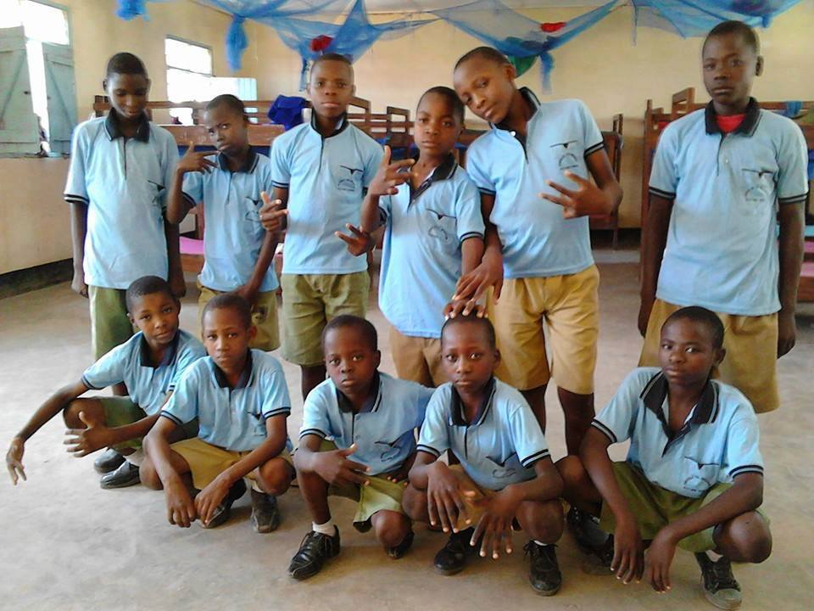

The scholarship students of the Kingiti Primary School in the remote Mpwapwa District of central Tanzania have enjoyed support from the Kingiti School Scholarship & Village Health Outreach Fund since 2009 with the birth of this organization in Kingiti village. Primary school in Tanzania is the equivalent of elementary and middle school in the US. In the first years, the organization became well known in the area for seeking out primary school-age children that were either orphaned or from families unable to provide the necessary supplies for them to attend school. Intervening in cases where the need was clear, we began providing these children with school uniforms, supplies, district medical cards, and school fees that include lunch. It is our commitment to fund these children in need until their graduation of primary school (Grade 7) and our great hope to be able to fund all of them as far as their aspirations and abilities may take them. We look forward to many more years of serving the children in greatest need in Kingiti village.

**Kingiti Primary School Head Teacher, Asha Bwanary (far left), and Kingiti Fund Project Director, Stanley Muhede (far right), with the rest of the primary school scholarship students in front of the schoolhouse.**

**The Kingiti Fund’s 2015 Kingiti Primary School Graduates**

The Kingiti Fund Quarterly

**Editor’s Note:**

It is with great pleasure we offer this first issue of The Kingiti Fund Quarterly. With this publication we hope to better engage and inform all of our generous supporters.

Always Grateful,

Ben Belknap, Tino Kasagula, and the Kingiti School Scholarship & Village Health Outreach Fund Board of Directors.

August 2015, Issue #1

# Kingiti Fund Scholarship Students of the Kingiti Primary School

**Jimmy, Lidia, and their daughter Salome on the beach in Dar (Mariamu and Benitho in center).**

A momentous goal was achieved in 2014 with the acceptance of two scholarship students from the Kibakwe Secondary School into the Ebonite Teacher’s College (ETC) in Dar es Salaam. Mariamu and Benitho (pictured above) received scholarships all four years of their secondary school education and, in becoming two of the extremely few people from their area to attend college, represent a tremendous achievement both personally for them and for this organization. After completion of his first year, we were thrilled to hear that ETC had offered Benitho a job working in the elementary school attached to the college. This job is a huge opportunity for this young man from Kingiti village, proving that he has what it takes to achieve his personal goals and make it in the big city. We will be here for him if he later decides to pursue a more advanced degree. Mariamu is currently living with her sister in Dar and seeking employment at local elementary schools. We would like to thank two of this organization’s greatest assets, Kingiti Fund board member Jimmy Newhall and Lidia Tsaxara, for coordinating their enrollment into ETC and for looking after these teenagers as they adjusted to life in Dar. Also, a special thanks to Michelle Santoro and her Mary Ryan Foundation for helping fund their education.

# Ebonite Teacher’s College

Theopista Suluti

Theopista (second from right) and family outside their home in Kingiti.

Theopista is the Kingiti Fund’s first scholarship student to be funded all the way from primary school into college. She will begin at Dodoma Teacher’s College this month, studying to become a primary school teacher. She graduated from Kibakwe Secondary School and passed the Form 5 entrance exam last year. Her mother raised Theopista and her four siblings alone in their traditional two-room mud home in the above photo taken during her primary school days. Theopista is the pride of her family as she becomes the second family member to complete secondary school and the first to go to college. Upon completion of her studies she wishes to return to her family in Kingiti to teach at the village primary school.

**The Kigwe Secondary School**

Two years ago, three graduates of the Kingiti Primary School were given scholarships to attend secondary school after achieving the necessary grades to advance. Secondary school in Tanzania is four years long and analogous to high school in the US, but attending secondary is an achievement few from the rural villages attain. The lack of a secondary school in Kingiti requires the brightest primary school graduates to be able to afford boarding and fees away from their homes in order to continue their education. The Kingiti Fund project directors work with the Kingiti Primary School Head Teacher, Asha Bwanary, to select students with the ability to advance but without the means to make this education possible. Pictured above are the three fortunate students now in the middle of their second year in Kigwe (Clockwise from top- Joselina, Nikodemas, and Albert).

For more Information and Donations…

Please visit www.kingiti.org for more information on this organization, our history, and all of our projects! Donations can be made via Paypal on the “Contacts & Donations” page of the website or mailed to: **1135 Charles St. Louisville, KY 40204**. All donations are tax deductible as we are a 501c3 nonprofit organization.

To see updates and photos straight from our project directors in Tanzania like our page at facebook.com/kingitifund!

MANY THANKS TO EVERYONE WHO MAKES THIS WORK POSSIBLE!!!

The Resilient Boys of the Kigwe School for the Deaf

The Kigwe School for the Deaf is the only school of its kind in this area of Tanzania. These students, unable to enroll in their local schools due to their disability, come from villages hours away to live at this school, learn sign language, and gain the basic education they are denied in rural Tanzania. Visiting this school and seeing the deep bond that develops between these children who are commonly ostracized in their own villages is truly amazing. Graduates have used their education to develop

a variety of skills allowing them to join the local workforce, many becoming mechanics and skilled technicians. A few of our ten scholarship students have expressed interest in eventually teaching at a deaf school. Their teacher, a man that serves as the Kingiti Fund’s Education Project Director, Tino Kasagula is fluent in sign language and lives on their campus in Kigwe. He describes them as the forgotten children of East Africa that are exceedingly grateful to be given this opportunity at an education.